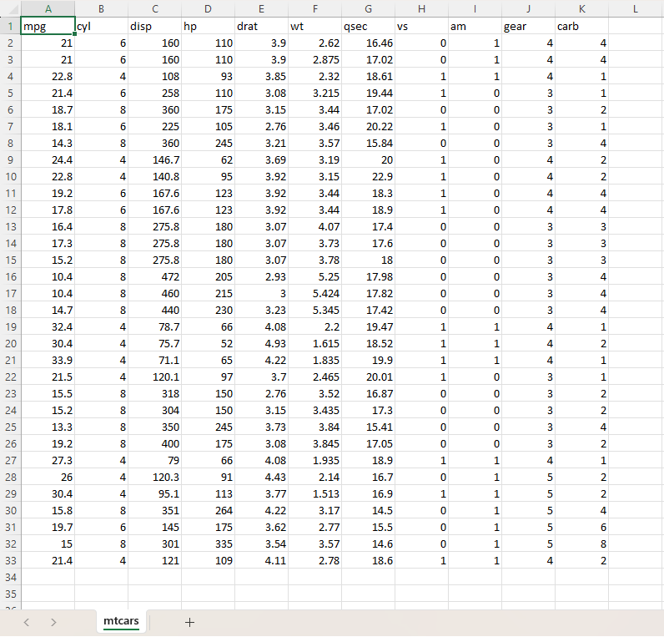
Name of Feature Description Type Relevance w.r.t other Features
1.mpg Miles per Gallon Quantitative, Continuous Relevant, it is the car fuel efficiency, miles
On one gallon of fuel
2.cyl Cylinders Quantitative, Discrete Relevant, no of cylinders in the engine
3.disp Displacement Quantitative, Continuous Relevant, the size of Engine in cubic inches
4.hp Horse Power Quantitative, Discrete Relevant, engine power output
5.drat Rear axle ratio Quantitative, Continuous Relevant, it affects acceleration and fuel
Economy
6.wt Weight of the car Quantitative, Continuous Relevant, it relates to weight of the car in 1000lbps
7.qsec Quarter mile (seconds) Quantitative, Discrete Relevant, Time to drive a quarter mile from a stop
8.vs Engine Type Quantitative, Binary Relevant, 0 = V-shaped engine, 1 = straight (inline) engine
9.am Transmission Type Quantitative, Binary Relevant, 0 = automatic, 1= normal
10.gear Forward Gears Quantitative, Binary Relevant, number of forward gears usually3,4,5
11.carb Carburetors Quantitative, Discrete Relevant, no. of carburetors, it affects
engine performance

